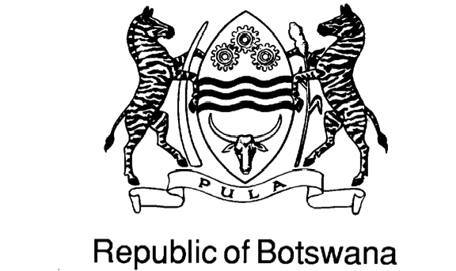

COUNTRIES WHICH DO NOT REQUIIRE VISA TO ENTER BOTSWANA

- Argentina
- Antigua and Barbuda 38. Namibia
- Australia 39. Nauru
- Austria 40. Netherlands
- Bahamas 41. New Zealand
- Barbados 42. Norway
- Belgium 43. Papua New Guinea
- Belize 44. Saint Kitts and Nevis
- Brazil 45. Saint Lucia
- Brunei Darussalam 46. St. Vincent & the Grenadines
- Canada 47. Samoa
- Cyprus 48. San Marino
- Denmark 49. Seychelles
- Fiji 50. Singapore
- Finland 51. Solomon Islands
- France 52. South Africa
- Gambia 53. Swaziland
- Germany 54. Sweden
- Greece 55 Switzerland
- Grenada 56. Tanzania
- Guyana 57. Tonga
- Hong Kong 58. Trinidad and Tobago
- Iceland 59. Tuvalu
- Ireland 60. United Kingdom
- Italy 61. USA
- Jamaica 62. Uganda
- Japan 63. Uruguay
- Kenya 64. Vanuatu
- Kiribati 65. Yugoslavia
- Lesotho 66. Zambia
- Liechtenstein 67. Zimbabwe
- Luxembourg
- Malawi
- Malaysia
- Maldives
- Malta
- Mauritius
- Mexico

